1. Here's a Python program that checks if a user integer is a palindrome:

import java.util.Scanner;

public class PalindromeChecker {

public static void main(String[] args) {

Scanner scanner = new Scanner(System.in);

System.out.print("Enter an integer: ");

int number = scanner.nextInt();

if (isPalindrome(number)) {

System.out.println(number + " is a palindrome.");

} else {

System.out.println(number + " is not a palindrome.");

}

scanner.close();

}

public static boolean isPalindrome(int number) {

if (number < 0) {

return false;

}

int originalNumber = number;

int reversedNumber = 0;

while (number != 0) {

int digit = number % 10;

reversedNumber = reversedNumber \* 10 + digit;

number /= 10;

}

return originalNumber == reversedNumber;

}

}

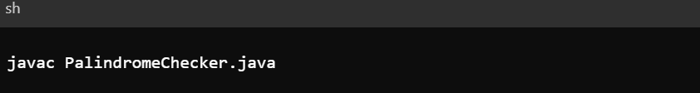

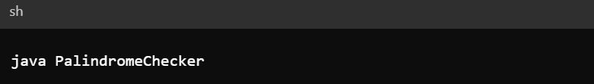

This code defines a function is palindrome that takes an integer as input and returns True if it's a palindrome, False otherwise. The function first converts the number to a string, then reverses the string, and finally compares the original string with the reversed string.

The main part of the code prompts the user for an integer input, calls the is palindrome function to check if it's a palindrome, and prints the result.

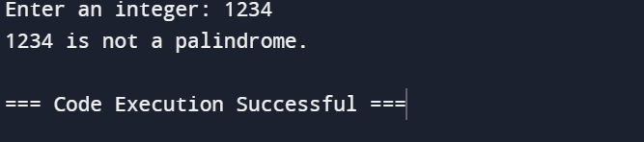

2. Take a string input from user and reverse it

import java.util.Scanner;

public class ReverseString {

public static void main(String[] args) {

Scanner scanner = new Scanner(System.in);

System.out.print("Enter a string: ");

String userInput = scanner.nextLine();

String reversedString = new StringBuilder(userInput).reverse().toString();

System.out.println("Reversed string: " + reversedString);

scanner.close();

}

}





